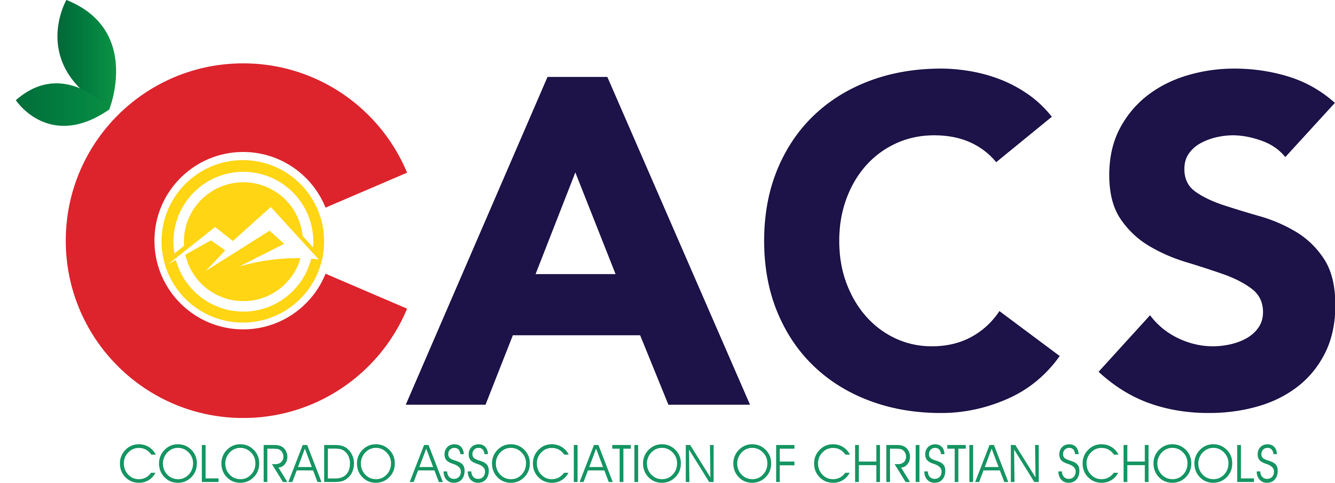

Rocky Mountain Christian Educators Conference
Teacher In-Service

Dear Administrator, Faculty, and Pastor,

I hope you are able to attend this year's conference. This letter provides information about the 2021 Rocky Mountain Christian Educators Conference (RMCEC). We have a great line-up of workshops and speakers and hope that you will come for the day. Along with this letter is an attendance list sheet for your school to complete and return with the appropriate registration fees as well as a tentative schedule of workshops.

Location: Beth Eden Baptist School
2600 Wadsworth Blvd.
Wheat Ridge, CO 80033

Date: Tuesday, August 10, 2021
9:00am – 4:00pm

Registration: The registration fee for each person from CACS Member schools (Pastors, Administrators, Faculty, and spouses) attending the conference is $25.00 (non-member fee is $30). Please send your school registration fees by July 23, 2021 by check made payble to CACS to:

CACS
FaithPoint
833 15th Avenue
Longmont, Colorado 80501

Speakers: We are fortunate to have as our speaker Mr. Renton Rathbun of Precept. He will speak at the general sessions. We will also have speakers from Bob Jones University, Pensacola Christian College, Precept, AACS, and Maranatha during several breakout sessions.

We look forward to fellowshipping and learning with you and your faculty at the Rocky Mountain Christian Educator’s Conference this year. If you have questions, please go to our web site at www.cacs-aacs.org for answers. Do not hesitate to contact me by e-mail, FAX, or phone if you have further questions.

Church phone: 970-434-4113
Cell phone: 970-270-2723
FAX: 970-434-8391
E-mail: rddavid2@gmail.com

In His Service,
Randy David
President of CACS

CACS Colorado Association of Christian Schools

Your School Name ______________________________________________________

Please provide a list of the names and Position of Pastors, Faculty, Staff, and Spouses who will attend the Rocky Mountain Christian Educators Conference from your school or church. Please return this information with your registration fee to CACS, FaithPoint, 833 15th Avenue, Longmont, CO 80501.

Name Position

1. ___________________________________________________________________________

2. ___________________________________________________________________________

3.____________________________________________________________________________

4._____________________________________________________________________________

5._____________________________________________________________________________

6.____________________________________________________________________________

7.____________________________________________________________________________

8.____________________________________________________________________________

9._____________________________________________________________________________

10.____________________________________________________________________________

11.____________________________________________________________________________

12.____________________________________________________________________________

13.____________________________________________________________________________

14.____________________________________________________________________________

15.____________________________________________________________________________

16.____________________________________________________________________________

17.____________________________________________________________________________

18.____________________________________________________________________________

19.____________________________________________________________________________

20.____________________________________________________________________________

Total number of staff attending ___________ X $25 = __________________

